Name:____________________________________________ Date:________________ Period: _______
Quiz 2A – Circular Motion (20 Points)

Draw a FBD for each of the following scenarios (Ignore Friction & Air Resistance). (3 points each)
1. A fighter jet pulls up from a dive. Draw the FBD for the pilot at the bottom of the curved path.

2. Car passes over a rise in a road. Passengers feel lighter. Draw the FBD for a passenger at the top of the path.

3. A fighter jet performs a vertical loop at constant speed. Draw/label the forces at Point A.

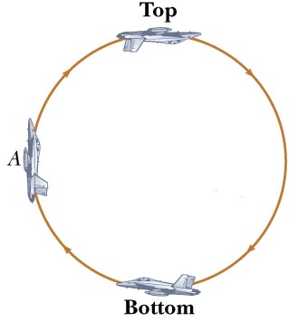

4. In the 1989 film Batman, the Caped Crusader evades the Joker by using a side-mounted grappling hook fired from the Batmobile to anchor a sharp left turn. The 2,300 kg vehicle executes this turn with a radius of 15 m while maintaining a constant speed of 30 m/s. The road is wet, resulting in a coefficient of static friction of 0.40. The road is level and the grappling cable is horizontal and anchored at the center of the turning arc.
A) Draw the FBD of the Batmobile (Ignore Air Resistance)
B) Calculate the minimum tension the cable must apply to make the turn. FBD (side view)

EXTRA PROBLEMS:
8) A circus performer rides their motorcycle inside a large metal sphere with a radius of 4 m. While moving in a horizontal circle, the 75 kg rider experiences 2.3 g’s when traveling at what speed?

FBD of rider (side-view)

Pro skater, Tony Hawk, completes a pass through a vertical loop on his skateboard. Coming out of the loop, he passes through the bottom with a speed of 6 m/s. If Hawk has a mass of 80 kg and the radius of the loop is 2 m, how many G's does he experience as he exits the loop?
FBD

